**Project Synopsis**

(DBDA – MARCH 2023 – Group-6)

**Project Title: -** UK Crime Data Analysis: Trends and Patterns

Our project is about descriptive analysis of UK police dataset.

We are creating a pipeline in which we have two different data sources and we are ingesting Uncleaned data into data lake and after preprocessing and transformation transferring enriched data into data warehouse for analysis using BI tools

**Problem Statement:**

Provide a holistic report to explore crime data using big data technologies and Power BI tool which reveal crime pattern, crime rate over period, location wise crime frequency, and assessment of legal system response for informed decision making, potential policy enhancements and ensure safe neighbourhood.

**KPI:**

1. To examine the evolution of crime rates.

2. To examine geospatial trends in criminal activity.

3. To analyse various types of crimes.

4. To estimate the time needed to reach a decision on any reported offense.

**Architecture:**

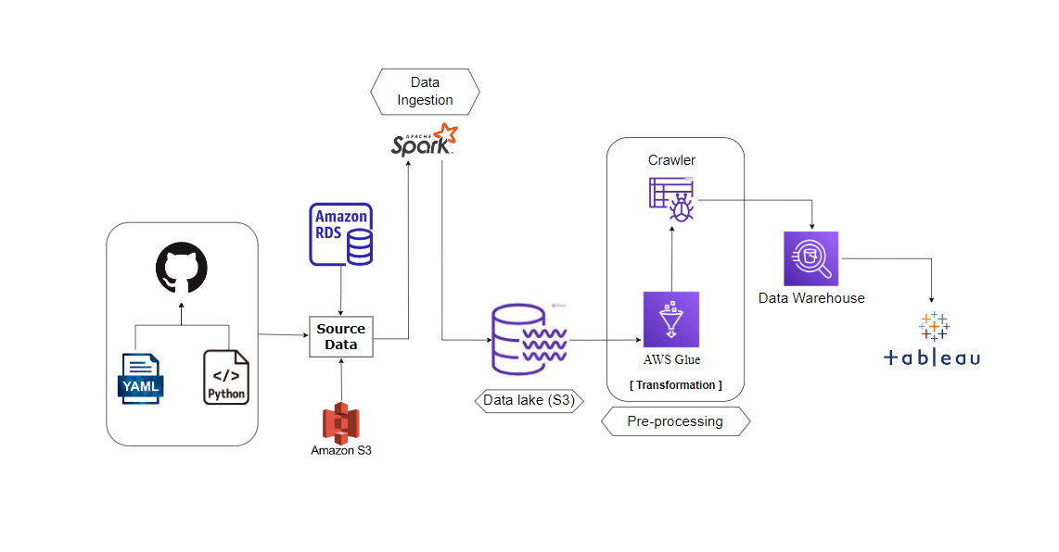

**Data Dictionary:**

**Master file (join of outcomes and street)**

|  |  |  |  |
| --- | --- | --- | --- |
| **SR.NO** | **COLUMN NAME** | **DATA TYPE** | **DESCRIPTION** |
| 1 | Crime ID | String | Unique identifier for the crime incident. |
| 2 | Month | Timestamp | Date and time of the crime occurrence. |
| 3 | Reported By | String | Entity or organization that reported the crime. |
| 4 | Falls within | String | Geographic jurisdiction where the crime falls under. |
| 5 | Longitude | Double | Geographic coordinates of the crime location. |
| 6 | Latitude | Double | Geographic coordinates of the crime location. |
| 7 | Location | String | Location of the crime scene. |
| 8 | Sub Crime Type | String | Specific sub-category or type of the crime. |
| 9 | Last Outcome category | String | The final status or category of the case (by police force). |
| 10 | Police Force Location | String | Location of the responsible police force. |
| 11 | Country | String | Country where the crime took place. |
| 12 | Crime Type | String | General category or type of the crime. |
| 13 | Date | Timestamp | Date and time when final verdict came. |
| 14 | Final Outcome | String | The ultimate resolution or outcome of the crime case (By court) |
| 15 | Months Between | Double | Time elapsed between the crime reported(month) and outcome (Date). |

**Stop And Search**

|  |  |  |  |
| --- | --- | --- | --- |
| **SR.NO** | **COLUMN NAME** | **DATA TYPE** | **DESCRIPTION** |
| 1 | Type | string | Data category or label. |
| 2 | Part of a policing operation | string | Association with larger police effort |
| 3 | Latitude | string | Geographic latitude coordinate. |
| 4 | Longitude | string | Geographic longitude coordinate. |
| 5 | Gender | string | Individual's gender (e.g., male, female, non-binary). |
| 6 | Age range | string | Age category (e.g., juvenile, adult). |
| 7 | Self-defined ethnicity | string | Self-identified racial background. |
| 8 | Legislation | string | Legal basis for search or action. |
| 9 | Object of search | string | Reason for the search (e.g., drugs, weapons). |
| 10 | Outcome | string | Result of police action. |
| 11 | Date Time | timestamp | Result of police action. |